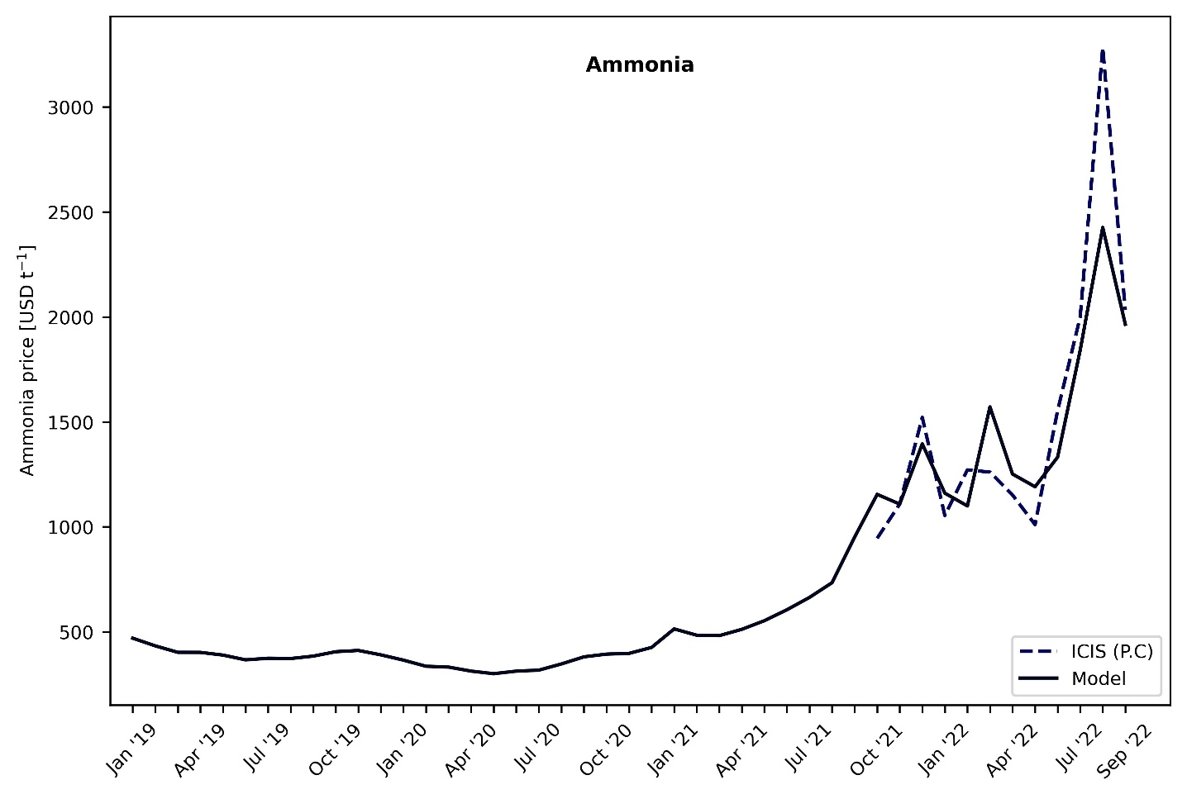
Figure 2 Ammonia cost of production (model) vs. production cost (literature)
The production cost of ammonia was calculated using our model and compared with the data extracted from ICIS. ICIS has published the production cost of ammonia for certain dates from October 2021 to October 2022 using the natural gas TTF spot prices. As shown in Figure 2, our model is in good agreement with the values from ICIS except at the peak. This divergence can be explained by understanding the prices used by ICIS. ICIS calculates the peak on 26th August 2022, where the natural gas prices were around 339 EUR MWh⁻¹, however we use monthly average prices in our analysis and for that reason the natural gas price we use at the peak (August 2022) is around 240 EUR MWh⁻¹.

